Coursework EE401: Advanced Comm. Theory

Part-A

“Multipath Spatiotemporal SIMO Wireless Systems”

**Task-1**

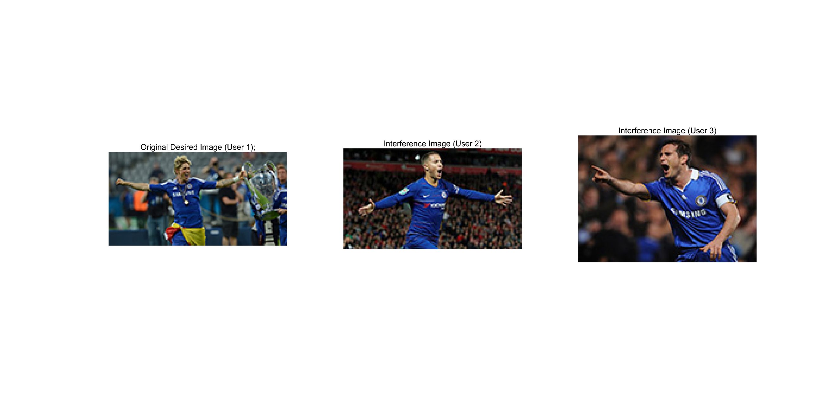

Figure 1 The digital photos transmitted by three users. The first one is the photo of desired user and the last two ones are the interference signal.

The bit sequences of these are firstly modulated using QPSK with the following constellation.

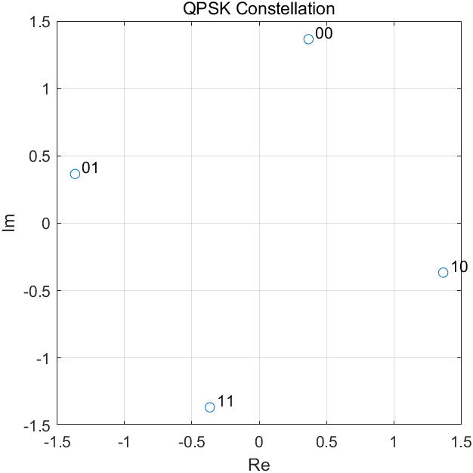

Figure 2 Constellation of QPSK modulation

The symbol sequence is spread by the Gold sequence. The Gold sequences of the three users are shown below.

|  |  |
| --- | --- |
|  | Gold Sequence |
| User 1 (desired user) | [1, -1, -1, 1, -1, -1, 1, -1, 1, 1, -1, -1, 1, 1, -1] *T* |
| User 2 | [-1, 1, -1, 1, 1, -1, 1, -1, -1, -1, 1, 1, 1, -1, -1] *T* |
| User 3 | [-1, -1, 1, 1, 1, 1, 1, -1, -1, 1, -1, -1, -1, -1, 1] *T* |

A RAKE receiver is designed simulated. The directions of arrival cannot be estimated as there is only one antenna at the receiver. The delay of desired user is estimated using a correlator. The interference signals from other 2 users are removed using the correlation property of Gold sequence. Two levels of noise (0db and 40dB) are compared.

* ***SNR = 0dB***

|  |  |
| --- | --- |
|  |  |

Figure 3 Image received by the RAKE receiver in the case where SNR=0dB (left). The constellation of the received symbols at the RAKE receiver (right).

* ***SNR = 40dB***

|  |  |
| --- | --- |
|  |  |

Figure 4 Image received by the RAKE receiver in the case where SNR=40dB (left). The constellation of the received symbols at the RAKE receiver (right).

In the case where there is only a single path of the desired signal, the quality of received signal is subject to the SNR. The received image has a high quality at a high SNR, while the received image is poor at low SNR.

**Task-2**

The difference between task-2 and task-1 is that there are more than one paths for the desired signal. Therefore, the Maximum Ratio Combination is applied at the RAKE receiver to exploit this diversity. Both the cases where the SNR=0dB and SNR=40dB are investigated.

|  |  |
| --- | --- |
|  |  |

Figure 5 Image received by the RAKE receiver in the case where SNR=0dB (left). The constellation of the received symbols at the RAKE receiver (right).

|  |  |
| --- | --- |
|  |  |

Figure 6 Image received by the RAKE receiver in the case where SNR=40dB (left). The constellation of the received symbols at the RAKE receiver (right).

In Figure 5, it is noticeable that the received image can have a high quality by exploiting the multipath diversity even at a low SNR.

**Task-3**

The difference between task-3 and task-1 is that there is antenna array at the receiver instead of a single antenna. Therefore, the antenna diversity can be exploited to enhance the quality of received signal. The locations of antenna array are shown below.

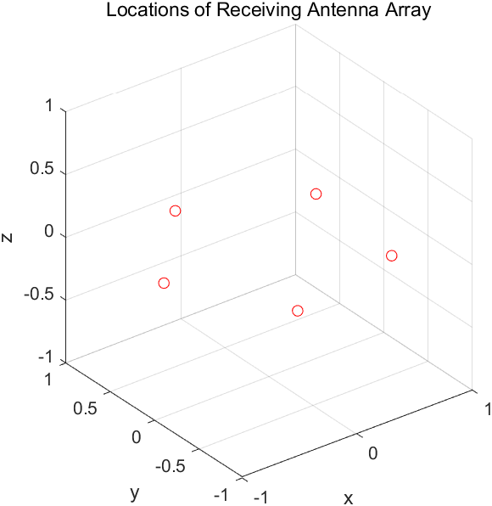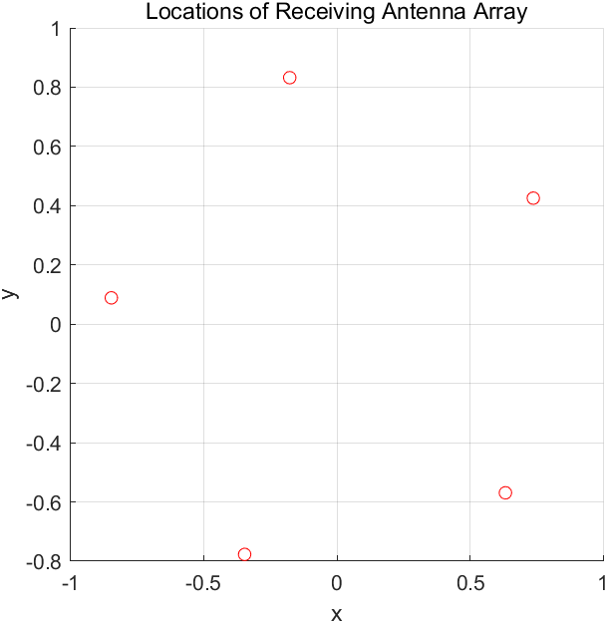

Figure 7 Locations of antenna array in two difference views.

Two kinds of receivers are designed for this Task-3, Decoupled Space and Time Receiver and STAR Receiver. SNR=0dB is assumed in this task.

* ***Decoupled Space and Time Receiver***

In this receiver, the directions of arrival (DOAs) are firstly estimated using the MUSIC cost function. The pattern of MUSIC cost function is shown below.

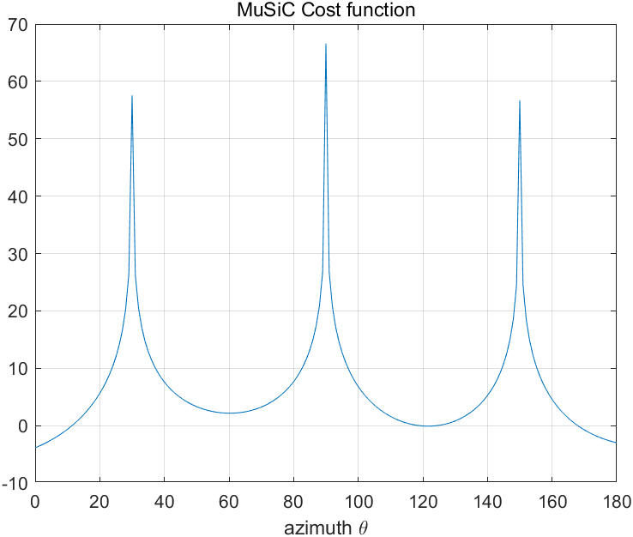

Figure 8 MUSIC cost function

The Figure 8 shows that there are three DOAs including [30,0], [90,0] and [150,0]. Assuming that which is the DOA of the desired user is known ([30,0]), a Superresolution Beamformer can be user the remove the effect of the signal with other two DOAs. The array pattern of the beamformer is shown below.

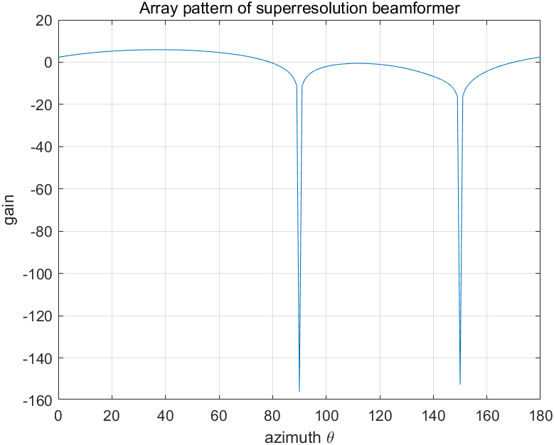

Figure 9 Array Pattern of Superresolution Beamformer

After eliminating the effect of other two paths, the delay of desired user is estimated using a correlator. Then the RAKE receiver developed in Task-1 and Task-2 can be used.

|  |  |
| --- | --- |
|  |  |

Figure 10 Image received by the Decoupled Space and Time receiver in the case where SNR=0dB (left). The constellation of the received symbols at the RAKE receiver (right).

This result indicates that by exploiting the antenna diversity, the high quality of the received image can be gained. However, the Decoupled Space and Time receiver conducts the estimation and detection tasks in space and time separately. And which one is the DOA of desired user is also assumed to be known. Therefore, the efficient and performance Decoupled Space and Time receiver is not good enough.

* ***STAR Receiver***

In this STAR receiver, the time and space are integrated using the extended array manifold which is called Spatiotemporal Array Manifold.

The received symbol chips are firstly extended by tapped delay line, after which the DOAs and delays of the desired user are jointly estimated using a 2D MUSIC-type cost function.

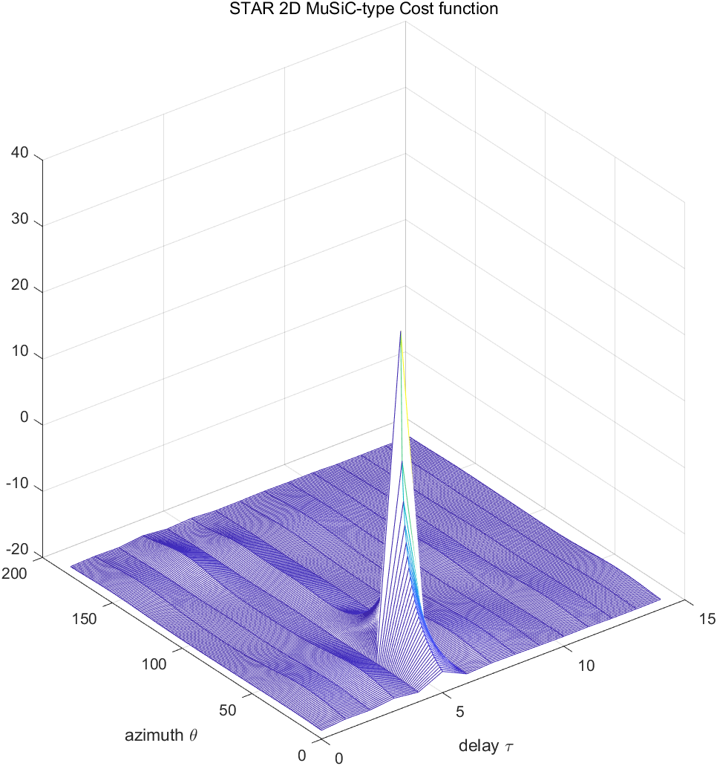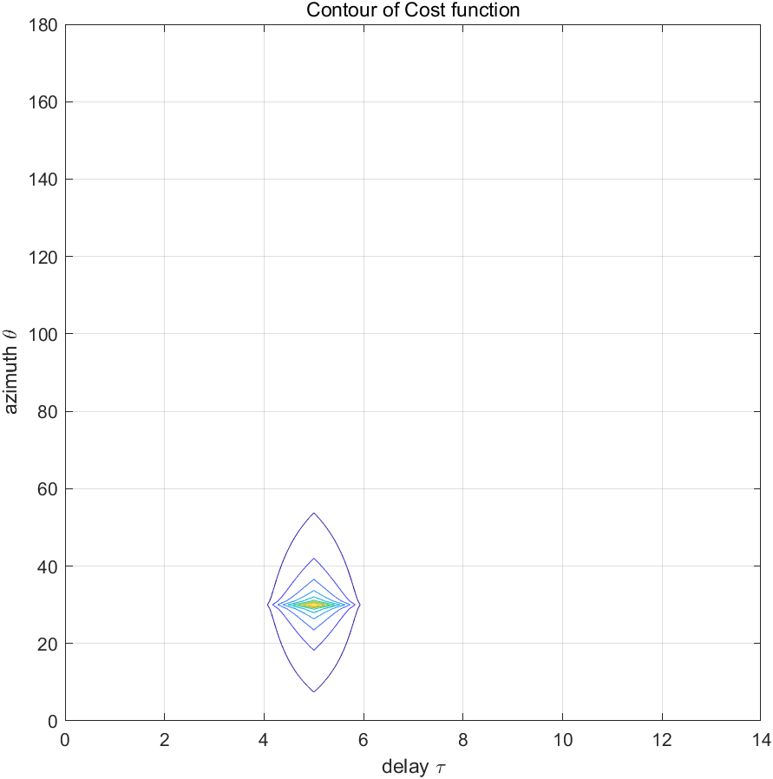 Figure 11 STAR 2D MUSIC-type cost function (left) and its contour (right).

The Figure 10 shows that the DOA of desired user is [30,0] and the delay of desired user is 5. There is no channel characteristic of other users estimated. For the reception of the desired signal, a spatiotemporal beamformer is used, whose array pattern is shown below.

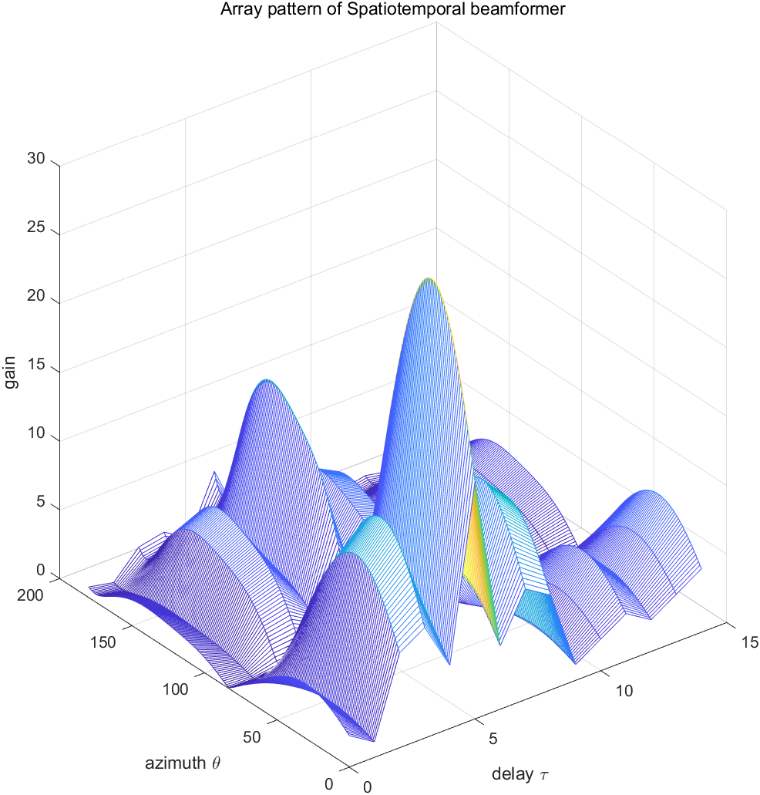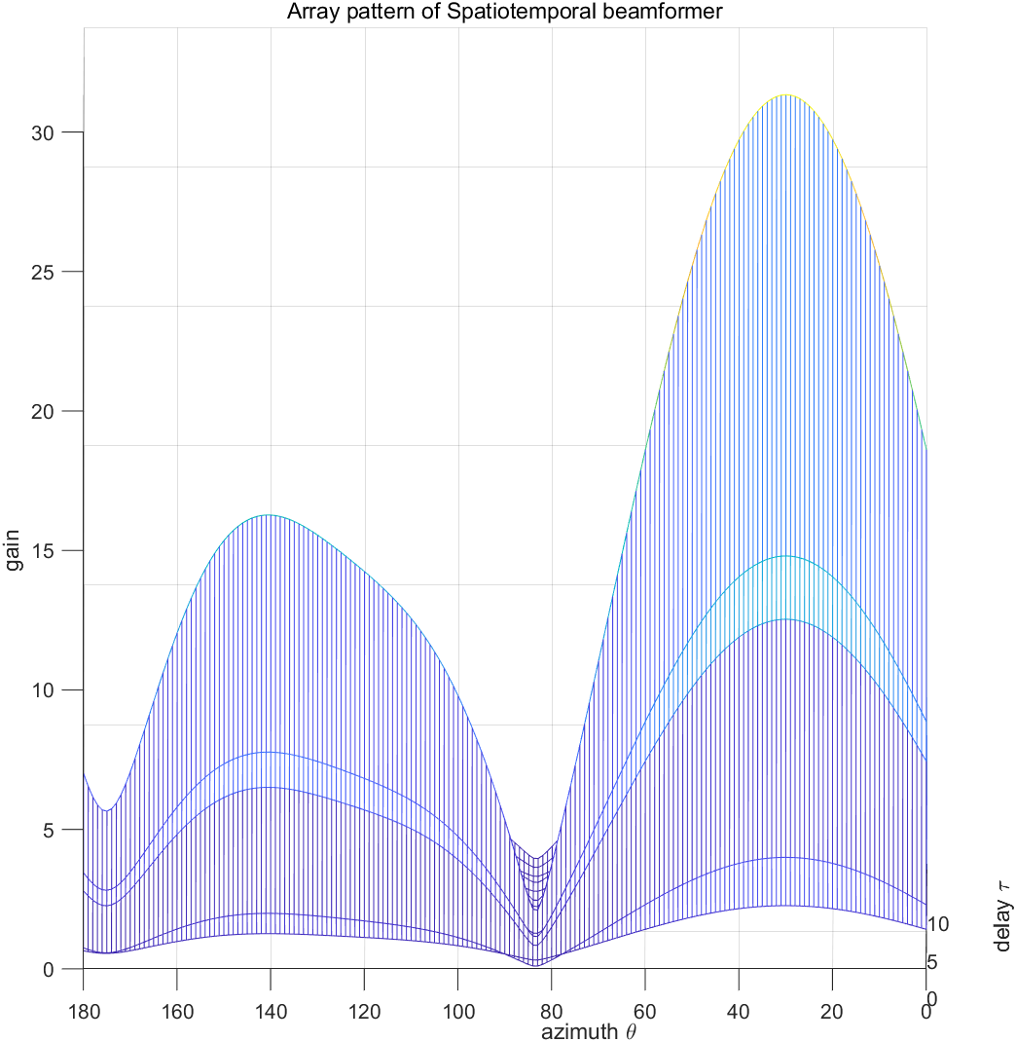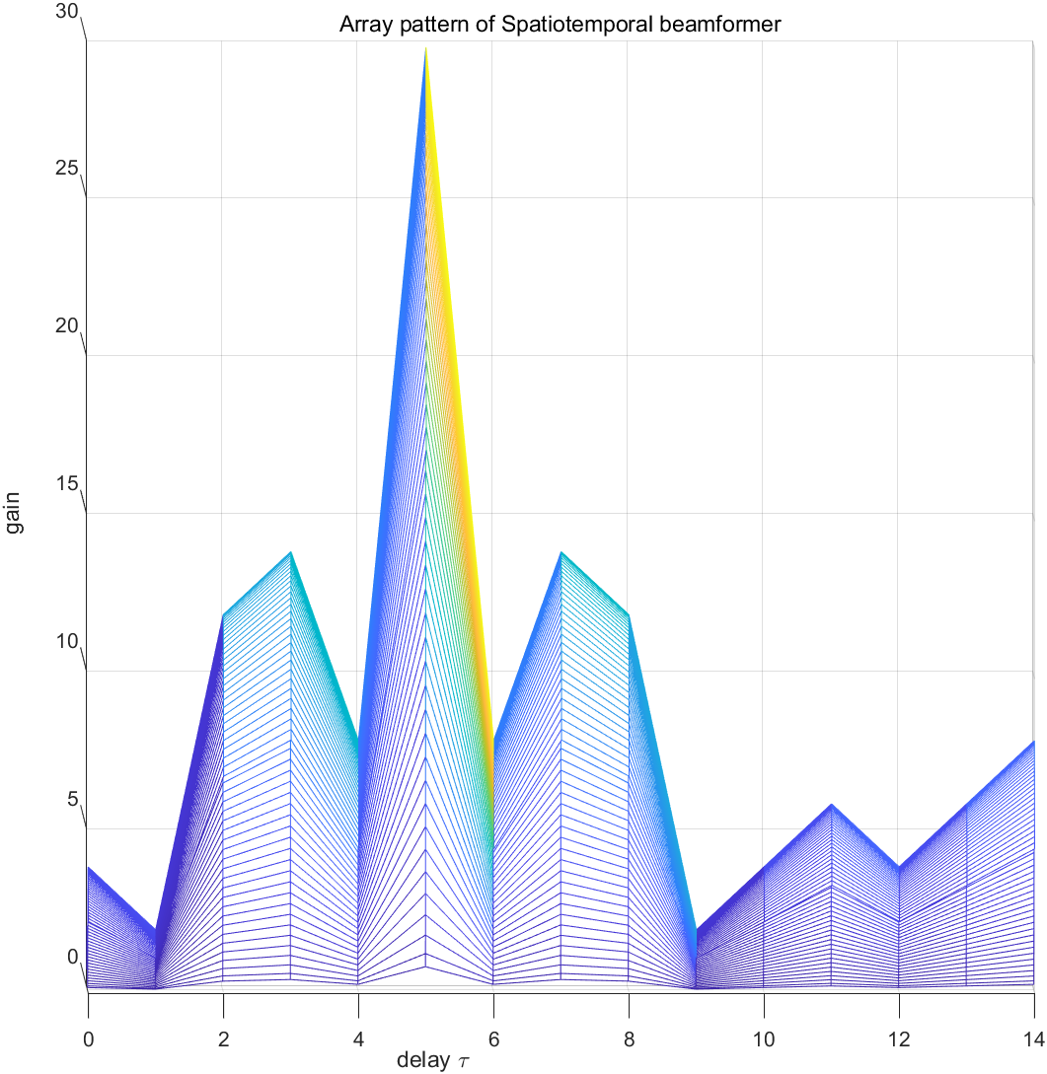

Figure 12 Spatiotemporal Beamformer in different views.

After applying the beamformer, the QPSK demodulation is applied. The received image is shown below.

|  |  |
| --- | --- |
|  |  |

Figure 13 Image received by the STAR receiver in the case where SNR=0dB (left). The constellation of the received symbols at the STAR receiver (right).

The high quality of received image can also be achieved. In STAR receiver, the space and time are integrated and there is no need to estimate the channel characteristics of the other users, which has a high efficiency.

**Task-4**

In this task, the STAR receiver is used. Firstly, the DOAs and delays of desired user is estimated.

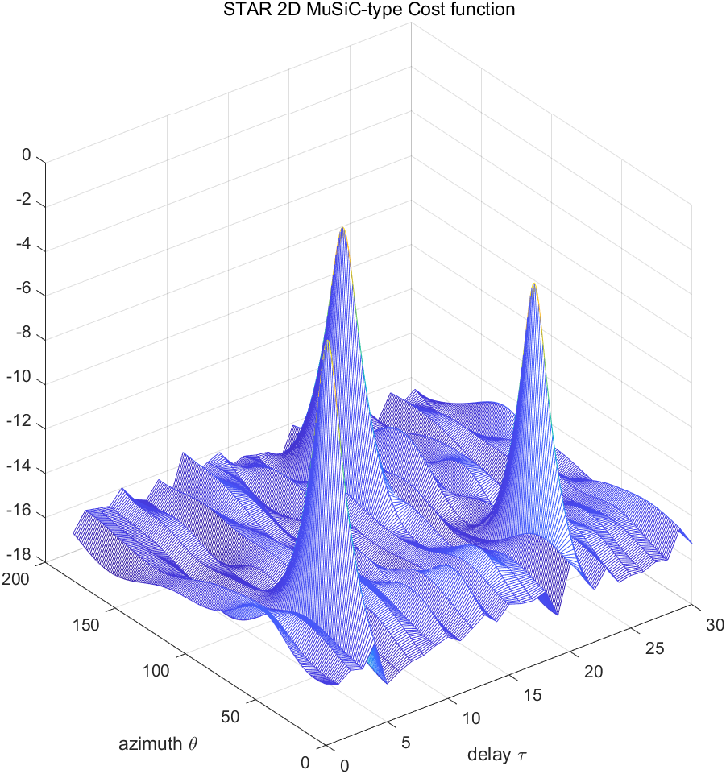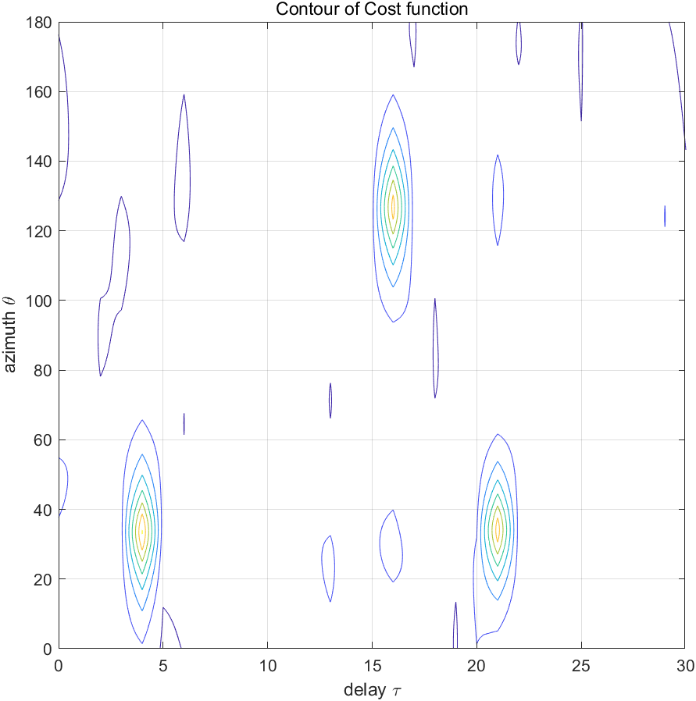

Figure 14 STAR 2D MUSIC-type cost function (left) and its contour (right).

According to the cost functions, there are three paths of the desired user. The DOAs are [34,0], [34,0] and [127,0] and the corresponded delays are 4, 21 and 16. A spatiotemporal beamformer is used to receive the desired signal, whose pattern is shown below.

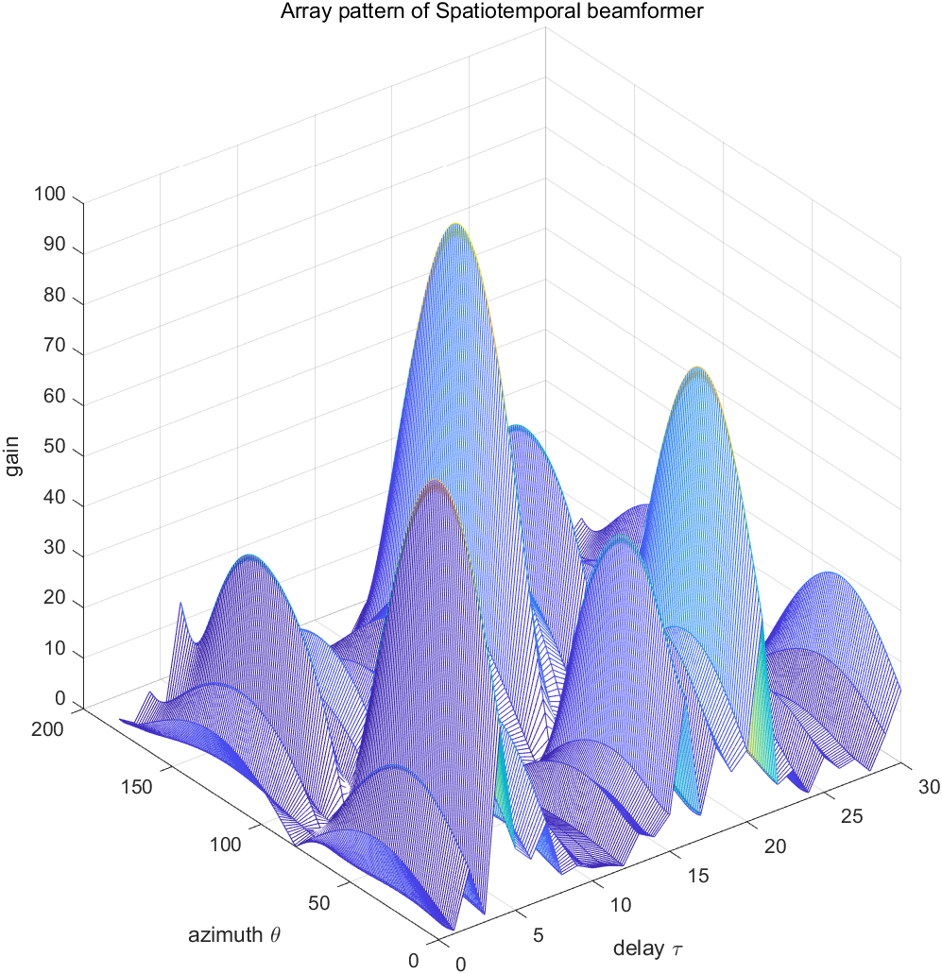

Figure 15 Array pattern of spatiotemporal beamformer.

The received bits are converted to characters using ASCII. The received 60 characters are

***Zhaolin, you are awesome!!! Mission accomplished!!!!!!!!!!!!***